Appendix 5

Exercise 1

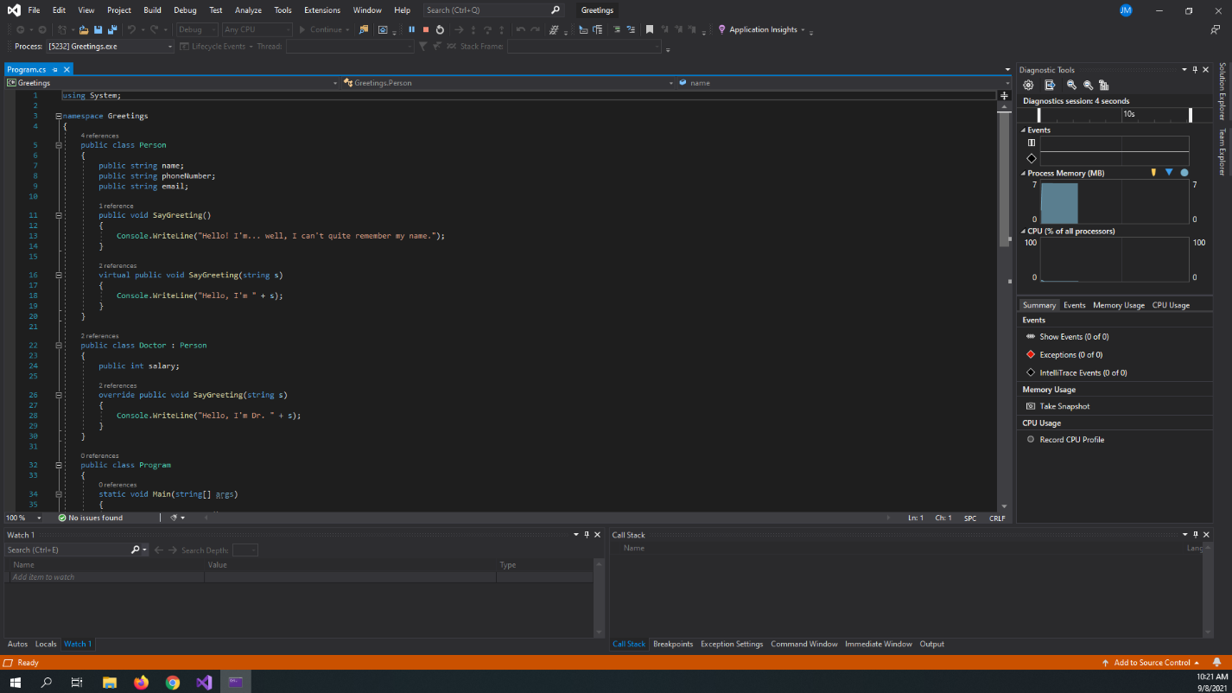

Exercise 2

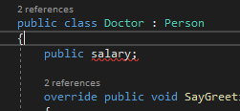

This error is saying the name “salary” does not exist in the context. We must first initialize it by saying what type of value salary is; in this case, an int.

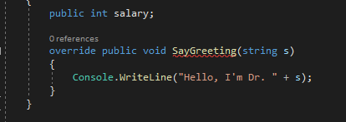

This error is saying we are trying to override a non-abstract or virtual method from the parent class. We must make the base class’ SayGreeting method either abstract or virtual to fix the issue.

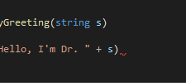

Lines must be ended by a ‘;’.

Exercise 3

<https://stackoverflow.com/>

Exercise 4



